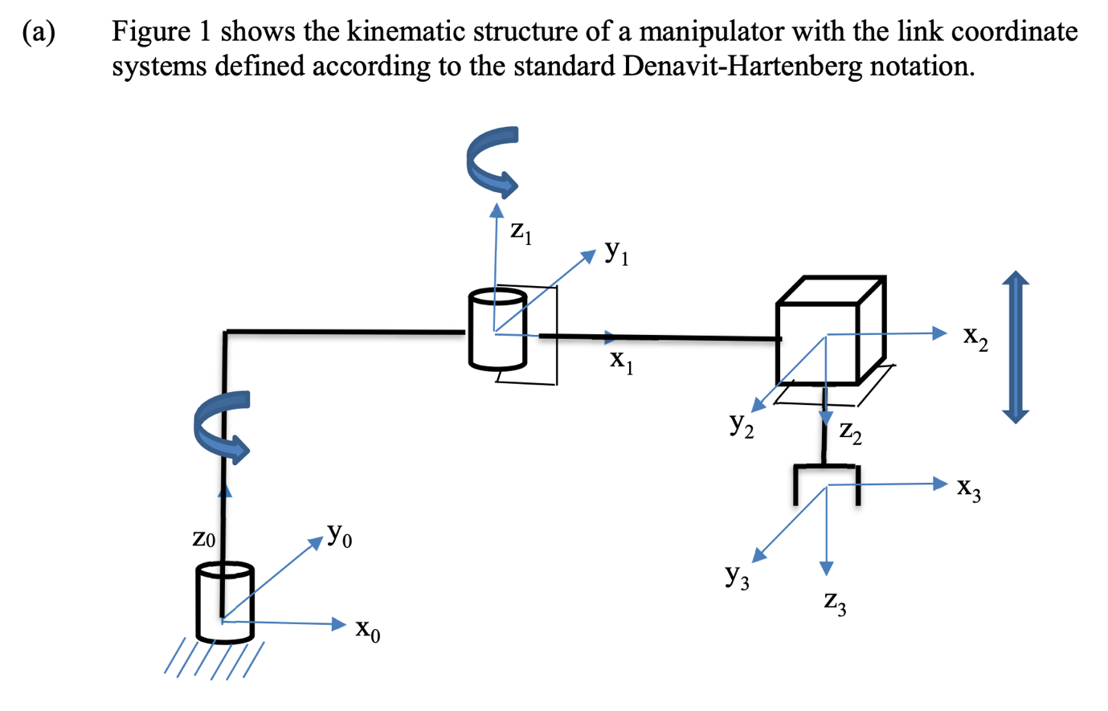



**(i)  Identify the kinematic parameters of the robotic manipulator and find the missing Denavit-Hartenberg parameters as shown in the table below.**

|  |  |  |  |  |
| --- | --- | --- | --- | --- |
| Link | $$θ$$ | $$d$$ | $$α$$ | $$a$$ |
| 1 | $$θ_{1}$$ | $$d_{1}$$ | 0 | $$a_{1}$$ |
| 2 | $$θ_{2}$$ | 0 | 0 | $$a_{2}$$ |
| 3 | $$θ_{3}$$ | $$d_{3}$$ | 180 $°$ | 0 |

**(ii)  Derive the forward kinematic equations of the manipulator.**

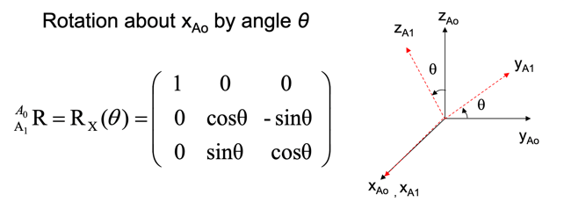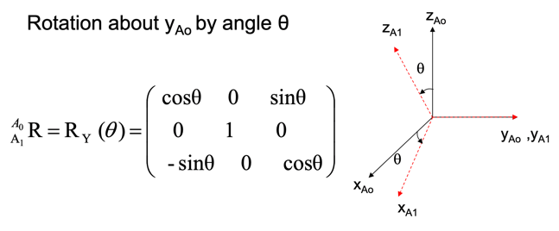

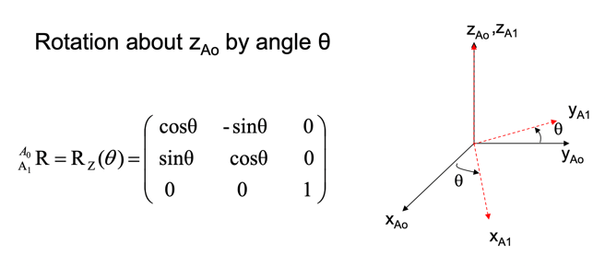

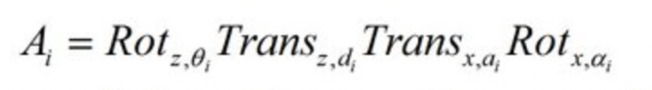

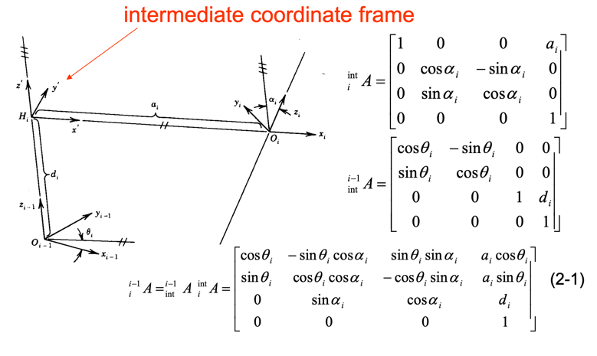

|  |  |  |  |  |
| --- | --- | --- | --- | --- |
| Link | $$θ$$ | $$d$$ | $$α$$ | $$a$$ |
| 1 | $$θ_{1}$$ | $$d_{1}$$ | 0 | $$a_{1}$$ |
| 2 | $$θ_{2}$$ | 0 | 0 | $$a_{2}$$ |
| 3 | $$θ_{3}$$ | $$d_{3}$$ | 180 $°$ | 0 |

$${}_{1}^{0}A=\left[\begin{matrix}\begin{matrix}cosθ_{1} & -sinθ_{1} \\ sinθ_{1} & cosθ_{1}\end{matrix} & \begin{matrix}0 & a_{1}cosθ_{1} \\ 0 & a_{1}sinθ_{1}\end{matrix} \\ \begin{matrix}0 & 0 \\ 0 & 0\end{matrix} & \begin{matrix}1 & d_{1} \\ 0 & 1\end{matrix}\end{matrix}\right]{}_{2}^{1}A=\left[\begin{matrix}\begin{matrix}cosθ_{2} & -sinθ_{2} \\ sinθ_{2} & cosθ_{2}\end{matrix} & \begin{matrix}0 & a_{1}cosθ_{2} \\ 0 & a_{1}sinθ_{2}\end{matrix} \\ \begin{matrix}0 & 0 \\ 0 & 0\end{matrix} & \begin{matrix}1 & 0 \\ 0 & 1\end{matrix}\end{matrix}\right]$$

$${}_{3}^{2}A=\left[\begin{matrix}\begin{matrix}cosθ_{1} & sinθ_{1} \\ sinθ_{1} & -cosθ_{1}\end{matrix} & \begin{matrix}0 & a_{1}cosθ_{1} \\ 0 & a_{1}sinθ_{1}\end{matrix} \\ \begin{matrix}0 & 0 \\ 0 & 0\end{matrix} & \begin{matrix}1 & d_{1} \\ 0 & 1\end{matrix}\end{matrix}\right]$$

$${}_{3}^{0}A= {}_{1}^{0}A{}_{2}^{1}A{}_{3}^{2}A$$

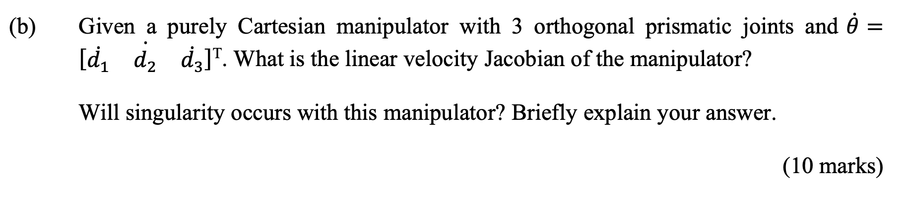

**计算正Jacobian**

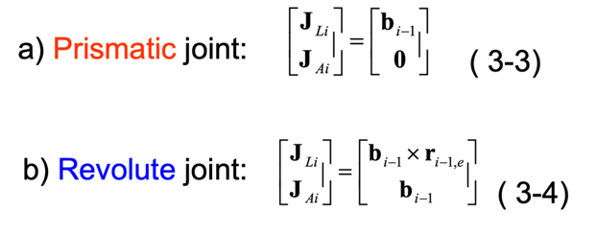

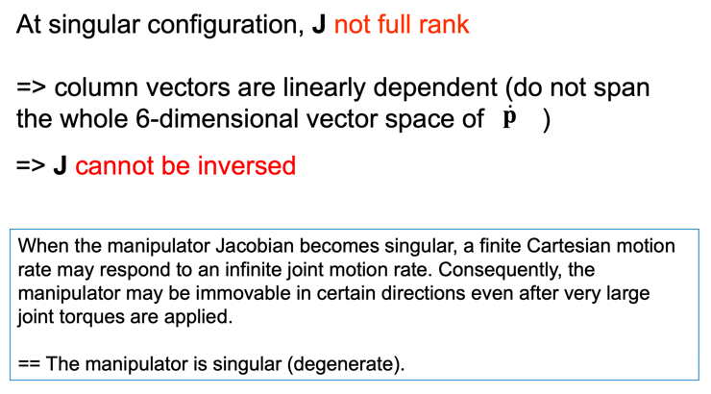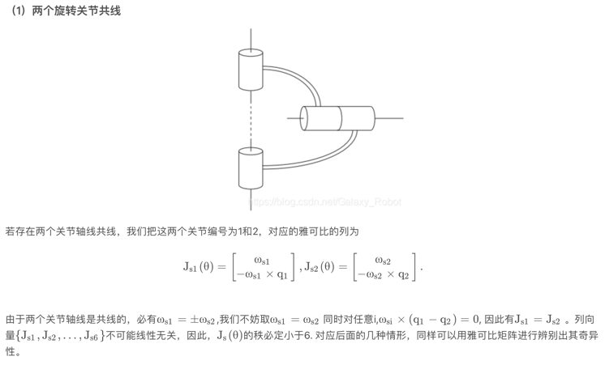

Singularity will occur. Because these three joints are in the same line and for one specific position will have multiple solutions which means the JL is not full rank and singularity will occur.

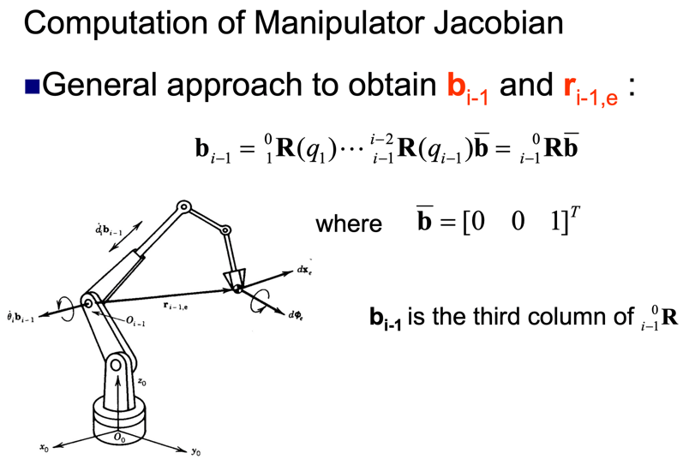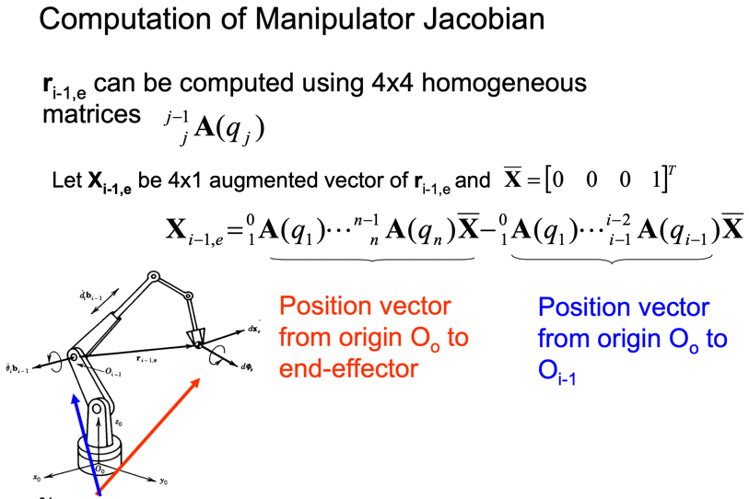

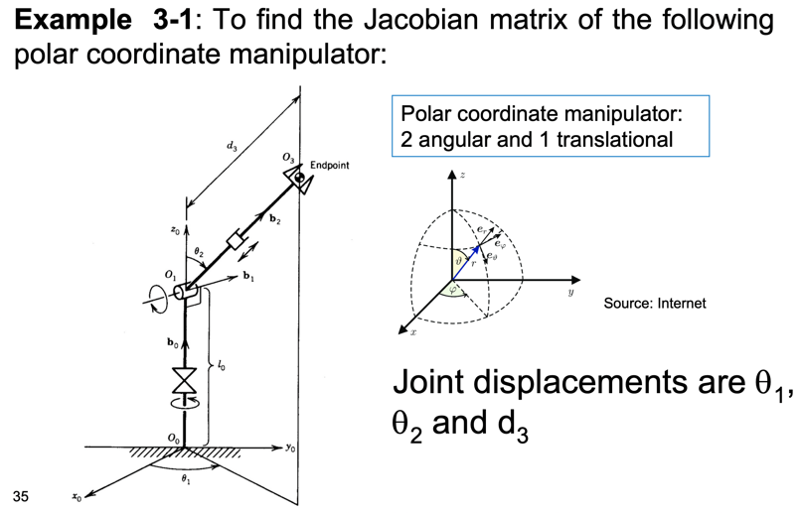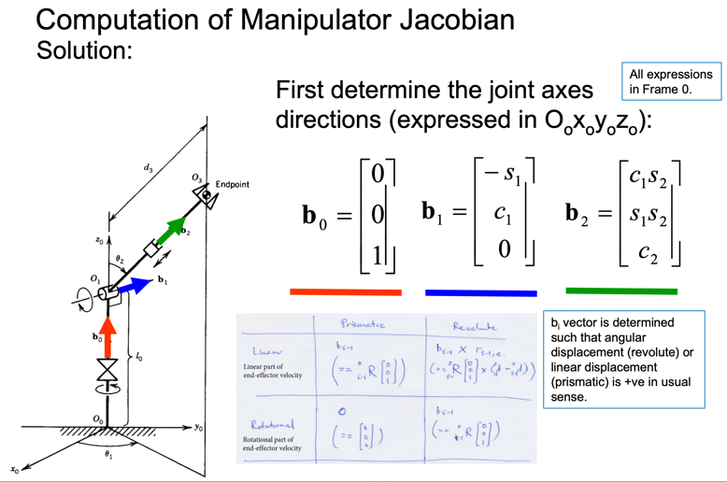

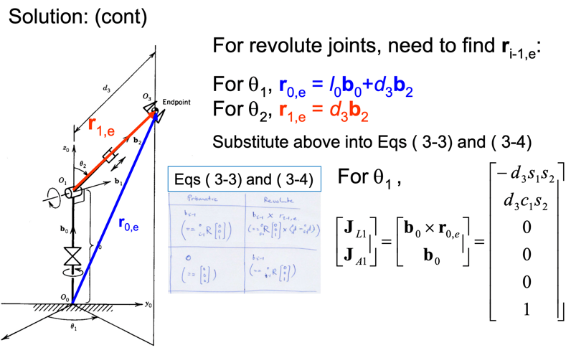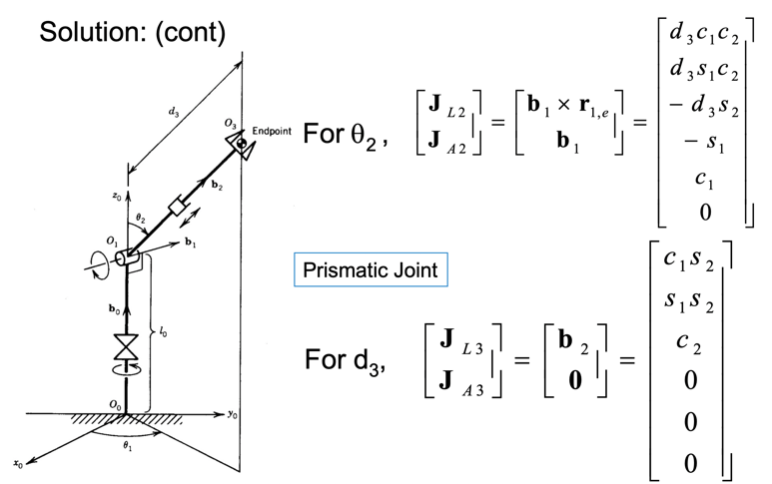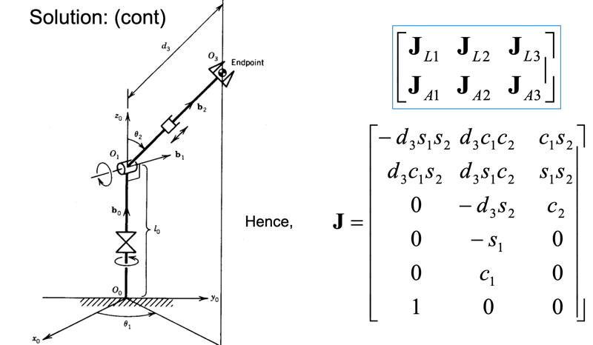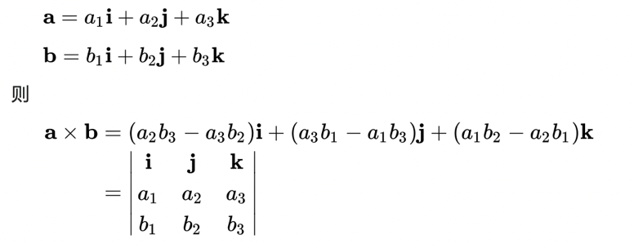

**差乘运算**

**计算逆Jacobian**

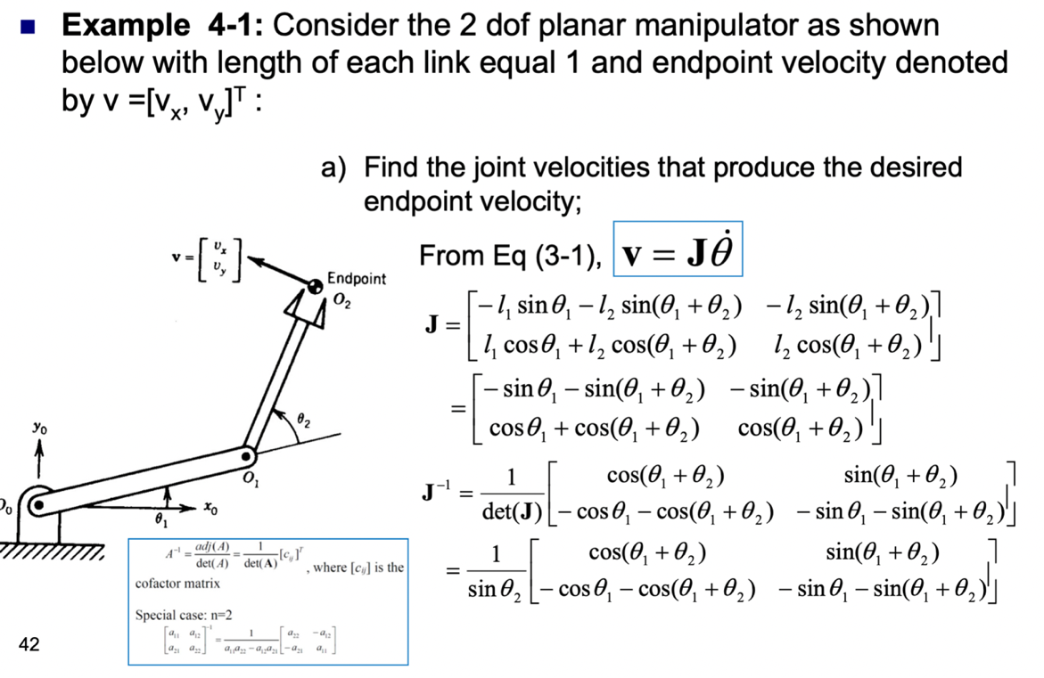

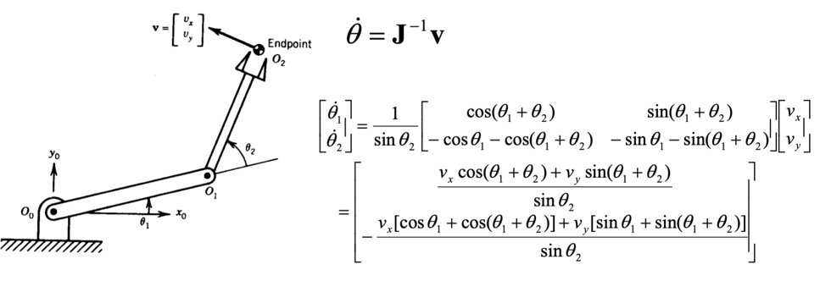

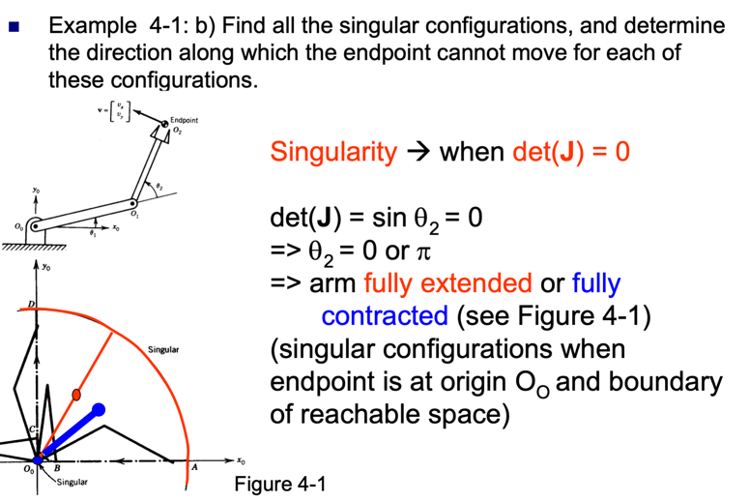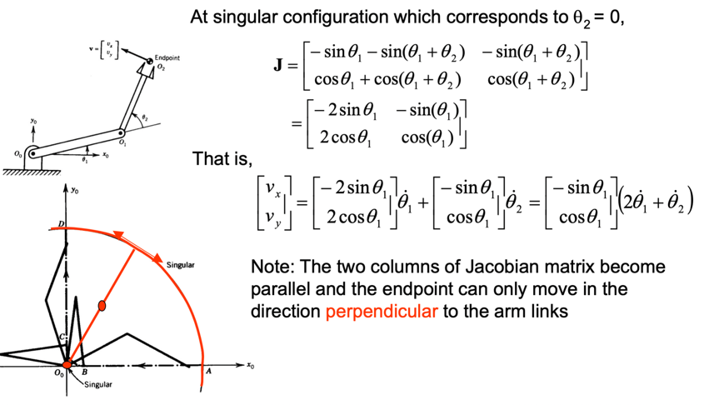

正弦函数定理：

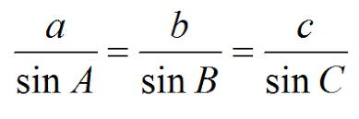

余弦函数定理：

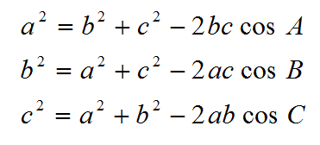

逆运动学

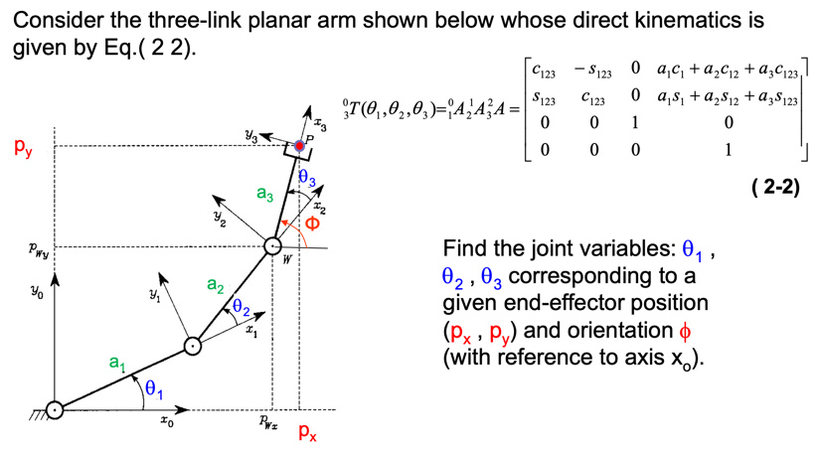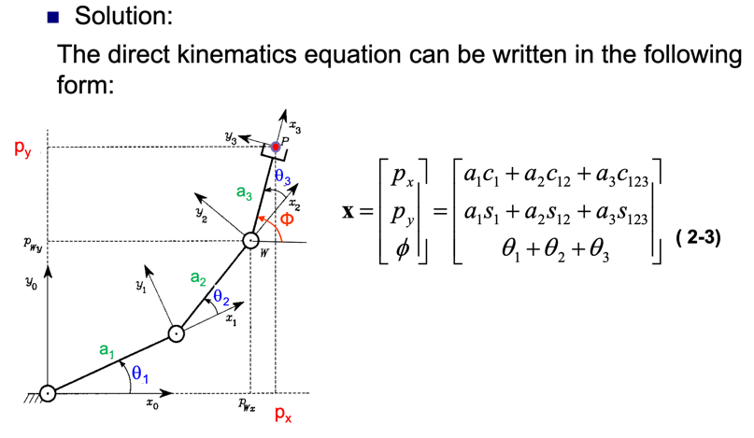

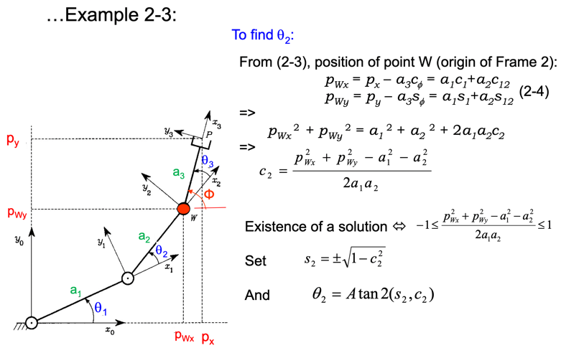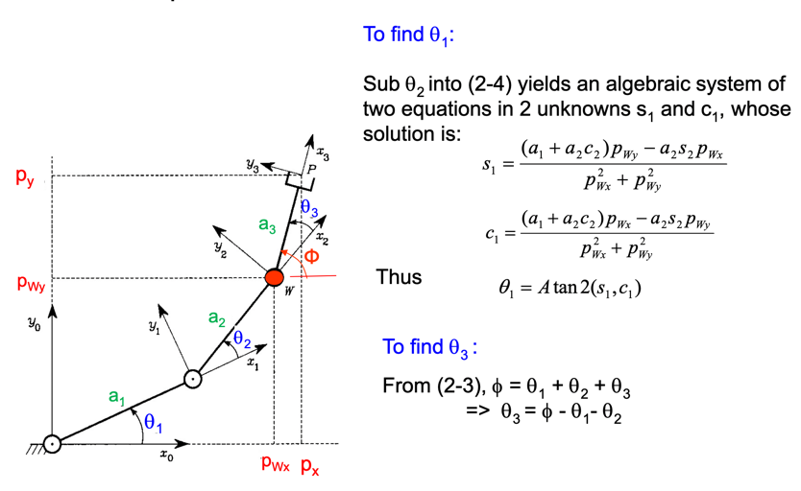

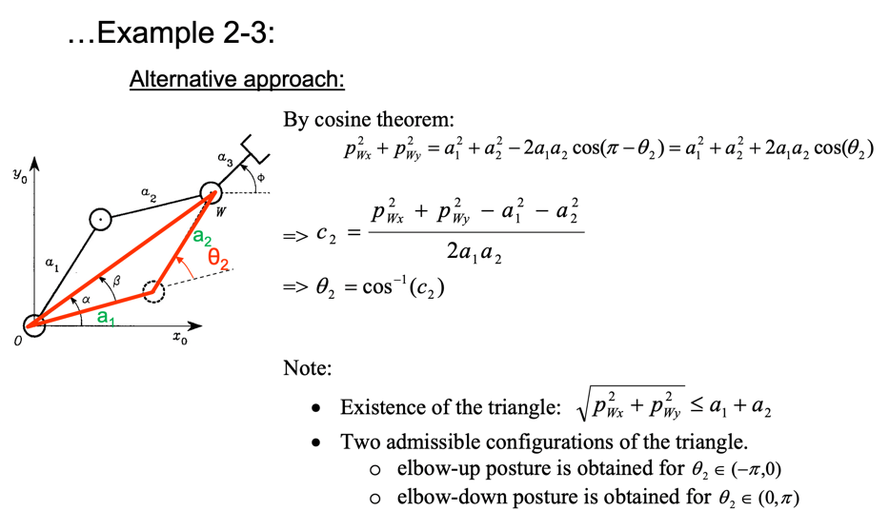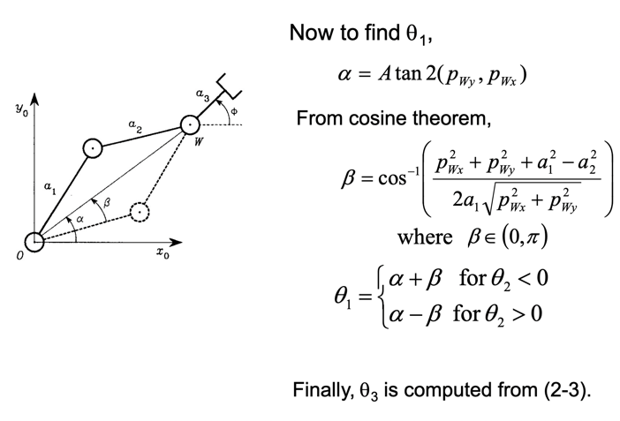

### 1.冗余机械臂的定义

对于机械臂来说，冗余的概念是相对的，是针对具体的任务来定义的，对于一个平面的任务，常用的6轴（六自由度）机械臂也是冗余的。但是更多的情况下，我们采用针对所有任务的情况，因为三维空间能用六个自由度进行描述，我们通常将7轴（七自由度）机械臂称为冗余机械臂。

**2.冗余机械臂的优势**

我们可以利用冗余机械臂多余的自由度来实现实现本体避障、避奇异、 避关节限位、关节力矩优化、增加操作度等附加任务。同时，由于人的一只胳膊也是有七个自由度，从仿生学的角度，冗余机械臂也比较符合实际。

1. Definition of Mingyu robotic arm

For the mechanical arm, the concept of Yu is relative and defined for specific tasks. For a plane task, the commonly used 6-axis (six-freedom) machine arm is also Mingyu. But in more cases, we will focus on all tasks, because the three-dimensional space can be described using six degrees of freedom. We usually refer to the 7-axis (seven degrees of freedom) robotic arm as the Mingyu robotic arm.

2. Advantages of Mingyu robotic arm

We can use the degrees of freedom of the redundant degrees of the registered mechanical arms to actually realize additional tasks such as avoiding failures, avoiding singularities, avoiding joint limit positions, optimizing joint forces, and increasing operating degrees. At the same time, since one human ear also has seven degrees of freedom, from the perspective of bionics, the SAE robot arm is more realistic.

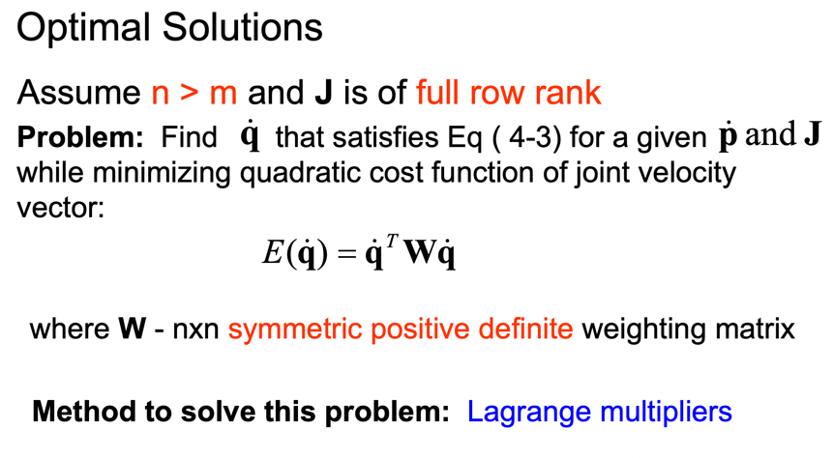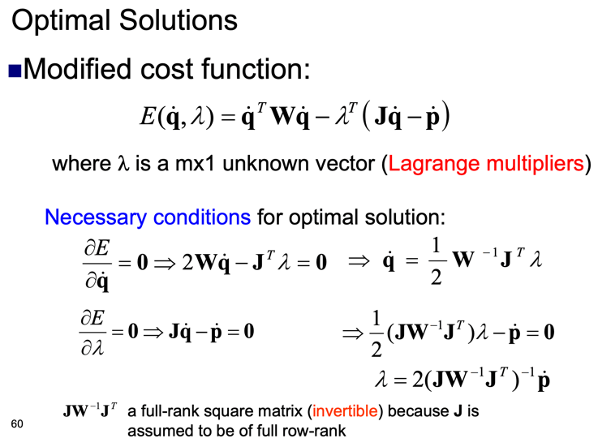

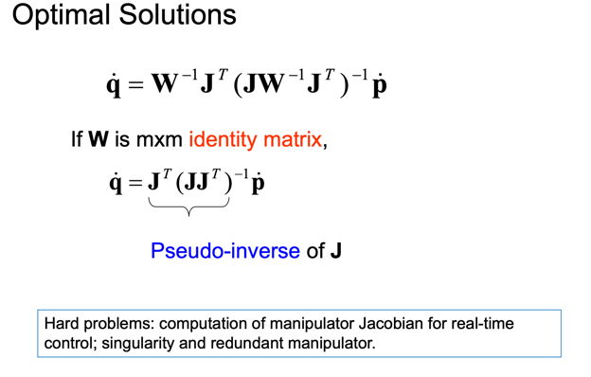

**末端施加力**

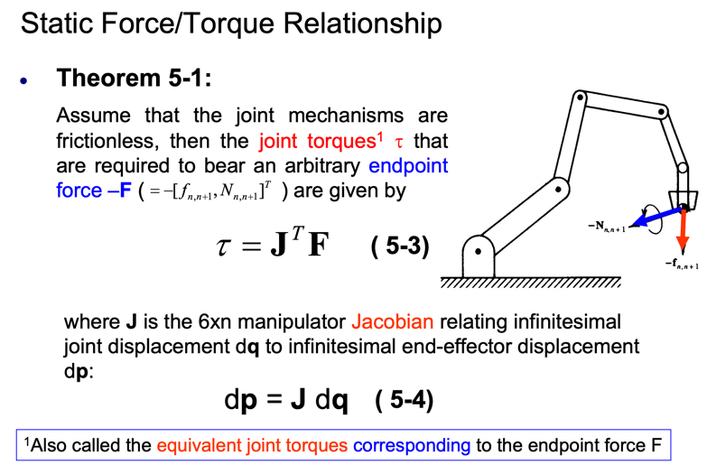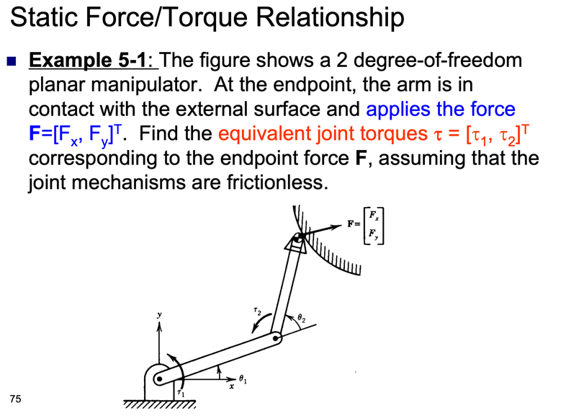

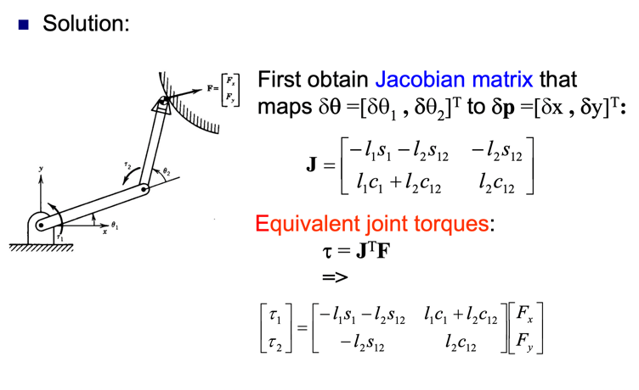

**Part2**











